Autumn 2023 F2 Recommended Reads

The Wonder by Faye Hanson
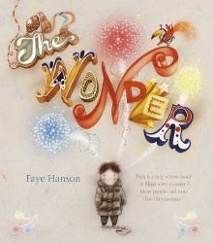
This is a story about a boy whose head is always full of wonder. We follow him on an average-seeming school day, where his daydreams transform the world around him. Unfortunately lots of other people - the park keeper, the bus driver, the lollipop lady - all tell him to get his head out of the clouds. It is only in art class that he realises he can bring the wonder out of his head for the whole world to enjoy.

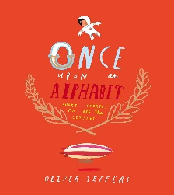
Once Upon an Alphabet by Oliver Jeffers
Here you will discover twenty-six short stories introducing a host of new characters (plus the occasional familiar face). From Edmund the astronaut with his awkward fear of heights, via the dynamic new investigative duo of the Owl and the Octopus, through to the Zeppelin that just might get Edmund a little bit closer to where he needs to be, this book is packed with funny, thrilling, perilous and above all entertaining tales inspired by every letter in the alphabet.

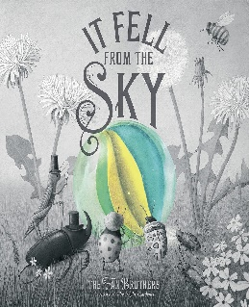
It Fell From the Sky by Eric Fan
It fell from the sky on a Thursday. None of the insects know where it came from, or what it is. Some say it’s an egg. Others, a gumdrop. But whatever it is, it fell near Spider’s house, so he’s convinced it belongs to him. Spider builds a wonderous display so that insects from far and wide can come to look at the marvel. Spider has their best interests at heart. So what if he has to charge a small fee? So what if the lines are long? But as Spider raises the prices, insects stop showing up, much to Spider's bemusement. And then, all of a sudden, an unexpected disaster hits and the marvel disappears!
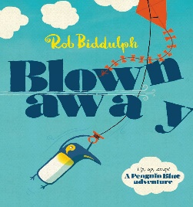
Blown Away by Rob Biddulph
Meet Penguin Blue, in this Waterstones Children’s Book Prize winning tale! It’s a windy day, and he has a brand-new kite – but where’s he going on this maiden flight? Penguin Blue and his friends go on a gloriously illustrated adventure full of good ideas, homesickness and the perils of kites, from the bestselling and multi-award-winnning Rob Biddulph, creator of the internet phenomenon Draw With Rob. As seen on YouTube, FaceBook, Instagram, CBeebies and TV news everywhere!
Hoot Owl by Sean Taylor
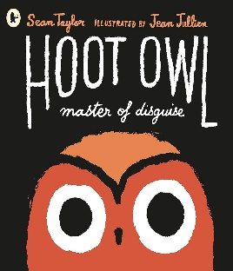
From masterful storyteller Sean Taylor and exciting, celebrated graphic artist Jean Jullien, comes the laugh-out-loud tale of Hoot Owl. Hoot Owl is no ordinary owl – oh no! – he’s a master of disguise! And he will use his expert camouflage powers to trick his unsuspecting prey into succumbing to him! Tiny animals of the night ... beware! But, somehow, Hoot Owl's prey keeps escaping... Hmmm, perhaps he isn't quite as masterful as he believes. Will he ever succeed in catching himself some dinner? Hilarity, ridiculousness and very bad costume changes abound in this wildly inventive new title.

