Autumn 2023 Year 1/2 Recommended Reads

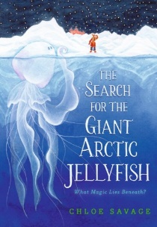
The Search for the Giant Arctic Jellyfish by Chloe Savage
Dr Morely sets out with all the proper equipment, all the right people, and years of careful planning to find a bizarre monster that no one has ever seen before. Will she be the first to see the enigmatic jellyfish? This is a great story of adventure, perseverance and resilience that will encourage children to never give up.

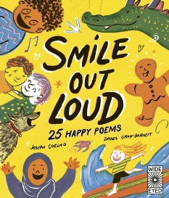
Smile Out Loud by Joseph Coelho
This book contains 25 exuberantly happy poems to read aloud. It features ‘The Dragging Dragon’, ‘Recipe For This Boy’ and many more. This is a great book to instil fun and inspire confidence when children read aloud or read chorally as part of a group.

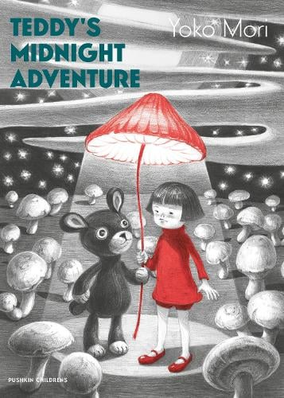
Teddy’s Midnight Adventure by Yoko Mori
Teddy has lost his button eye, so he and Akiko walk through a moonlit world to try and find it. Everything seems different and mysterious at night. Nut by the time the sun comes up, there’s a happy ending. A magical story of friendship.

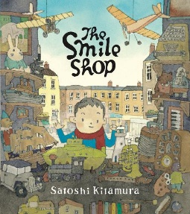
The Smile Shop by Satoshi Kitamura
When a young boy decides to go shopping for the first time, just before he decides to buy something he loses his pocket money. Disaster! But then he discovers a ‘Smile Shop’ and wanders in. A lovely modern fable.

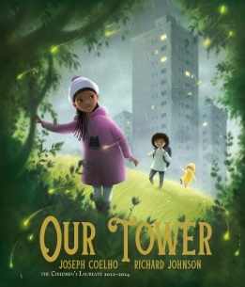
Our Tower by Joseph Coelho and Richard Johnson
Three children escape from their tower block into a fantasy land of magic and adventure in this modern fable. This book will spark children’s writing about their own lives and homes.

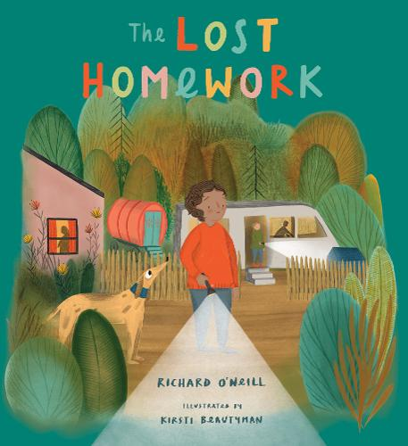
The Lost Homework by Richard O’Neill
Sonny has lost his homework and is worried about how his teacher will react. As he searches for his missing book, the reader learns about Sonny’s life as a Traveller, which includes going to a traditional wedding, helping his neighbours, and repairing one of the caravans they live in. This book shows children how all lives are different.

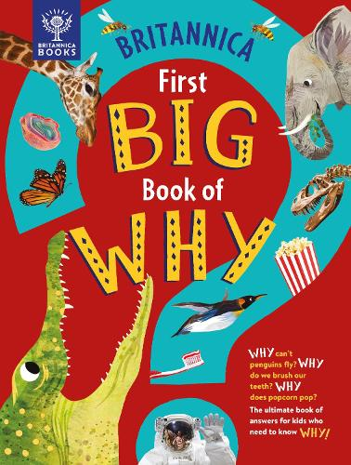
Britannica First Big Book of Why by Sally Symes and Stephanie Warren Drimmer
This is a wonderful non-fiction book to keep children interested and asking questions. It has bold graphics and eye catching photography as well as fun quizzes.

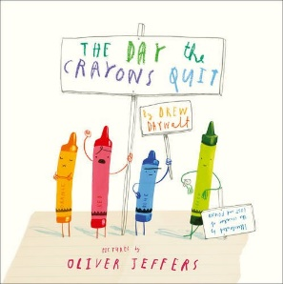
The Day the Crayons Quit by Oliver Jeffers
When Duncan opens his box of crayons, instead of colours, he sees letters spelling ‘We Quit!’. This hilarious story is full of bright illustrations and will appeal to the humour of any Year 2 child!

