Autumn 2023 Year 3/4 Recommended Reads

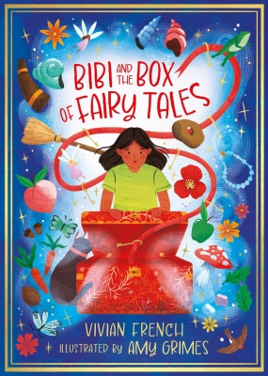
Bibi and the Box of Fairytales by Vivian French
Bibi doesn't believe in fairies. But when she meets her fairy godmother, the tiniest of hopes flickers in her mind. Seven quests to seven lands that will open a magic box and grant her a wish.... could it, just possibly, be true?
Whisked away with her trusty companion, Sylvestro the cat, Bibi quests with giants, dragons, princes and princesses, wizards, witches, water sprites and sea elves, unicorns, trolls and gnomes... Can Bibi earn the keys to open the box.... and unlock her belief in fairy magic?

The Dog That Ate the World by Sandra Dieckmann
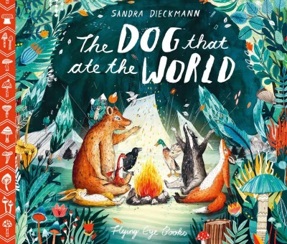
He came over the pastures like a mean thunderstorm… fast as lightening was the dirty dog. All of the animals of the valley lived in peace and harmony until the big greedy dog appeared. He was so greedy that he gobbled up everything he could see! Happily for our animal friends, there was plenty of room for them all to live and play in the dog’s big bad belly. Perhaps it’s not so great to be the biggest and baddest animal in the valley after all…

The Midnight Fair by Gideon Sterer
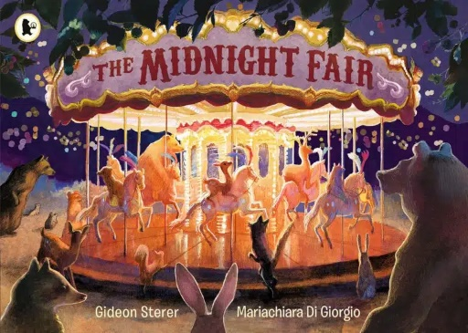
A spectacular, surreal and cinematic wordless picture book about the secret life of animals. Far from the city, but not quite in the countryside, lies a fairground. When night falls, and the fair is empty, something unexpected happens. Wild animals emerge from the trees, a brave raccoon pulls a lever, and the rollercoasters and rides explode back into bright, neon life. Now it’s time for the woodland creatures to have some fun…

The Invisible by Tom Percival
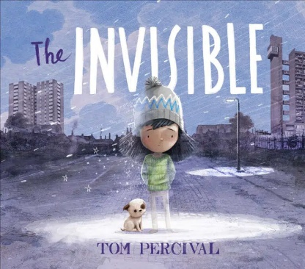
A moving, powerful story that shines a light on those that feel invisible in our world – and shows us that we ALL belong – from the author of Ruby’s Worry .
The Invisible is the story of a young girl called Isabel and her family. They don’t have much, but they have what they need to get by. Until one day, there isn’t enough money to pay their rent and bills and they have to leave their home full of happy memories and move to the other side of the city.
It is the story of a girl who goes on to make one of the hardest things anyone can ever make…a difference.

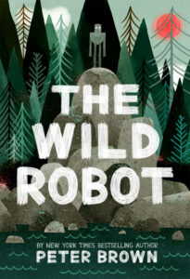
The Wild Robot by Peter Brown
When robot Roz opens her eyes for the first time, she discovers that she is alone on a remote, wild island. She has no idea how she got there or what her purpose is – but she knows she needs to survive. After battling a fierce storm and escaping a vicious bear attack, she realises that her only hope for survival is to adapt to her surroundings and learn from the island’s unwelcoming animal inhabitants. As Roz slowly befriends the animals, the island starts to feel like home – until, one day, her mysterious past comes back to haunt her.

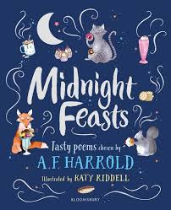
Midnight Feasts by A. F. Harrold
What are your food memories? Your temptations, the taste ticklers, the deep indulgences? A. F. Harrold has harvested a feast of food-flavoured poetry in ‘Midnight Feasts‘. Poetry from a wide variety of nations, palates and experiences is shared in this banqueting book.

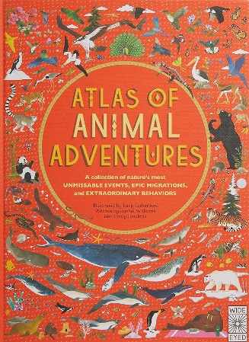
ATLAS OF ANIMAL ADVENTURES by Emily Hawkins and Rachel Williams
From the team behind the bestselling Atlas of Adventures, this journey of discovery takes you in large format through 31 of nature’s most unmissable animal events from between the two poles. Celebrate the incredible ways in which animals survive in the wild, from epic migrations and extraordinary behaviours to Herculean habits. There are hundreds of things to spot and facts to learn with every turn of the page, as you’ll meet another of nature’s most adventurous creatures, learning about their amazing behaviours and habitats.

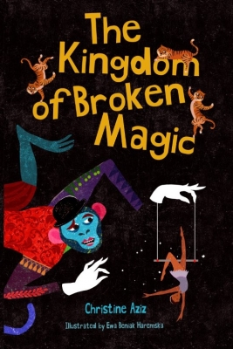
The Kingdom of Broken Magic by Christine Aziz
A whirlwind of a story with talking tigers, a knitting elephant and a sinister monkey. In the Kingdom of Broken Magic, who can you trust? Streetwise pickpockets, Maggie and Josh, are inseparable. Only their friendship makes life bearable at the Scribbens Home for Very Wayward Children, run by the villainous Miss Scribbens. But when Maggie encounters a strange and sinister circus, she abandons Josh and tumbles headfirst into a world of dangerous and dazzling magic. She's determined to solve the mystery of its disappearing performers and animals. Where do they go? Who is the mastermind behind it all? Josh sets out to find Maggie, unaware of the dark dangers that lie ahead.

