Interesting texts - Science
Year 1
Seasonal Changes  Tree: Seasons Come, Seasons Go  (Patricia Hegarty and Britta Teckentrup)  One Year with Kipper  (Mick Inkpen)  After the Storm  (Nick Butterworth)  The Rhythm of Rain  (Graham Baker Smith)  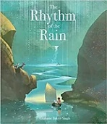  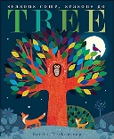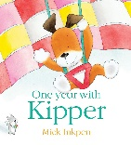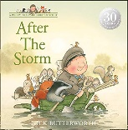 | Animals, including humans  RSPB: My First Book of Garden Birds  (Mike Unwin and Sarah Whittley)  Snail Trail  (Ruth Brown)  Superworm  (Julia Donaldson & Axel Scheffler)  Bog Baby  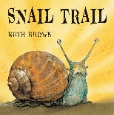  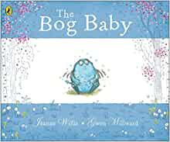  (Jeane Willis)  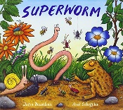  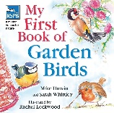 | For more texts linked to science, check out the websites below:  https://www.booksfortopics.com/science  https://www.stem.org.uk/teaching-science-through-stories  First news
Plants  A Little Guide to Wild Flowers  (Charlotte Voake)  The Things That I LOVE about TREES  (Chris Butterworth)  Harry’s Hazelnut  (Ruth Parsons)  Jack and the baked beanstalk  (Colin Simpson)  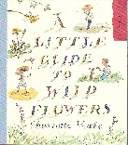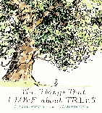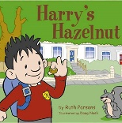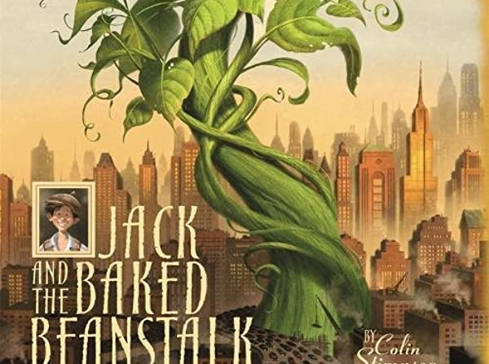 | Materials  The Great Paper Caper  (Oliver Jeffers)  Who Sank the Boat  (Pamela Allen)  Beegu  (Alexis Deacon)  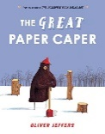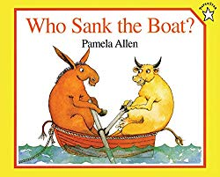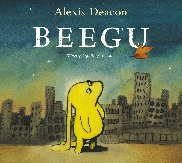

Year 2
Living things and their habitats  Lost and found  (Oliver Jeffers)  The Gruffalo  (Julia Donaldson)  The Secret of Black Rock  (Joe Todd Stanton)  Creature Features  (Natasha Durley)  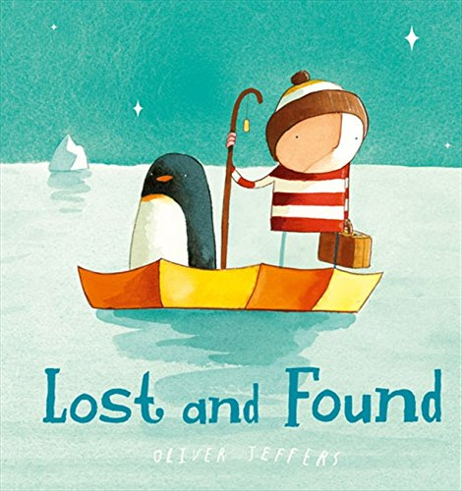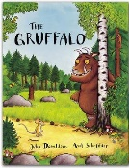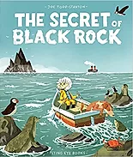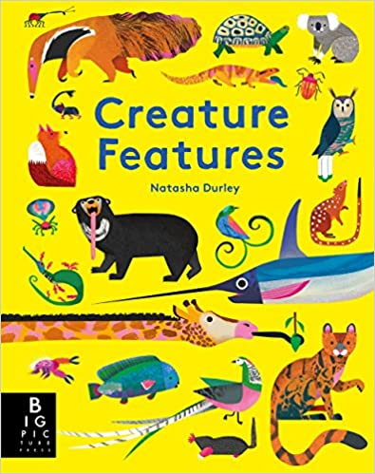 | Animals, including humans  Handa’s Surprise  (Eileen Brown)  Once There Were Giants  (Martin Waddell and Penny Dale)  Tadpole's Promise  (Jeanne Willis and Tony Ross)  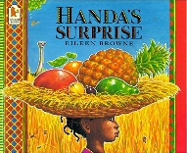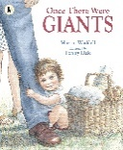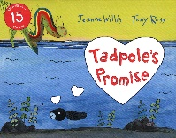 | For more texts linked to science, check out the websites below:  https://www.booksfortopics.com/science  https://www.stem.org.uk/teaching-science-through-stories  First news
Plants  Ten Seeds  (Ruth Brown)  A Seed Is Sleepy  (Dianna Aston)  Wild  (Emily Hughes)  The Last Wolf  (Mini Grey)  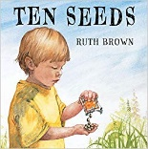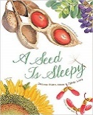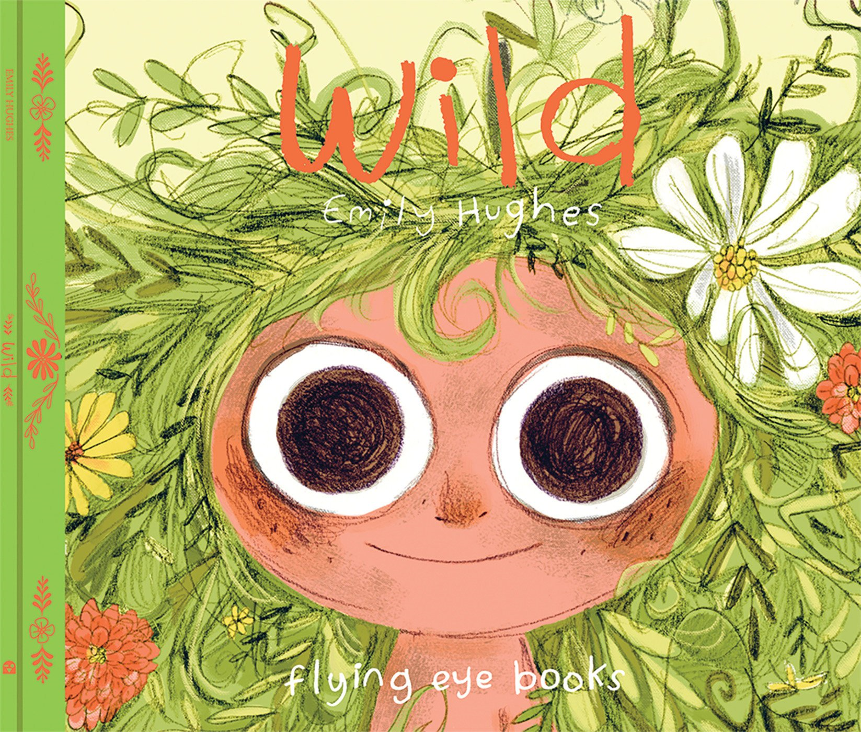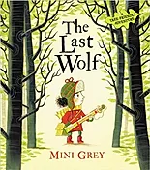 | Materials  The Tin Forest  (Helen Ward)  Traction Man  (Mini Grey)  Three Little Pigs  (Lesley Sims)  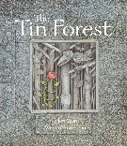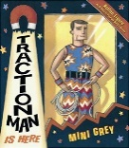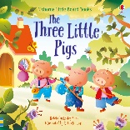

Year 3
Plants  The Story of Frog Belly Rat Bone  (Timothy Basil Ering)  The Hidden Forest  (Jeannie Baker)  British Wild Flowers  (Nature detective)  The Bee Book  (Charlotte Milner)  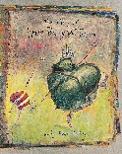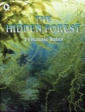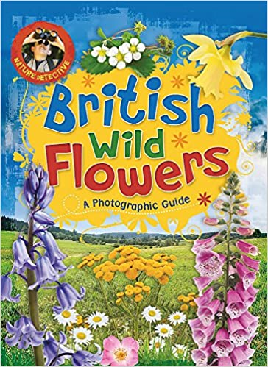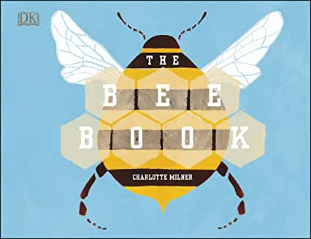 | Animals, including humans  Funnybones  (Janet and Allan Ahlberg)  I Will Never Not Ever Eat a Tomato  (Lauren Child)  Goldilocks and the Three Bears  (Samantha Berger)  Book of Bones: 10 Record-Breaking Animals  Gabrielle Balkan & Sam Brewster  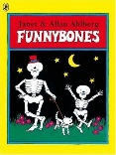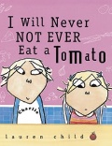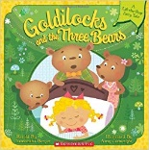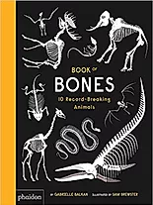 | Forces and Magnets  The Iron Man  (Ted Hughes)  Mrs Armitage: Queen of the Road  (Quentin Blake)  Mr Archimedes’ Bath  (Pamela Allen)  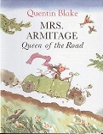  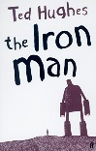  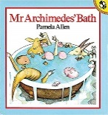
Rocks  The Pebble in My Pocket  (Meredith Hooper)  Stone Girl, Bone Girl  (Laurence Anholt)  The Street Beneath My Feet  (Charlotte Guillain & Yuval Zommer)  Mary Anning  (History VIP)  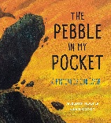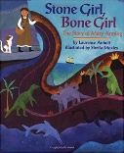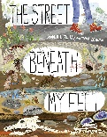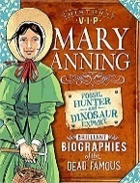 | Light  The Owl Who Was Afraid of the Dark  (Jill Tomlinson)  The Dark  (Lemony Snicket)  The Firework-Maker's Daughter  (Philip Pullman)  Orion and The Dark  (Emma Yarlett)  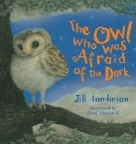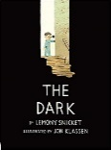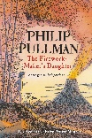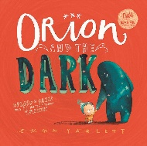 | For more texts linked to science, check out the websites below:  https://www.booksfortopics.com/science  https://www.stem.org.uk/teaching-science-through-stories  First news
Year 4
Living things and their Habitats  The Vanishing Rainforest  (Richard Platt)  When the Mountains Roared  (Jess Butterworth)  Lots: The Diversity of life on Earth  (Nicola Davies)  The Promise  (Nicola Davies)  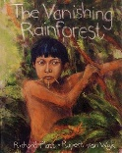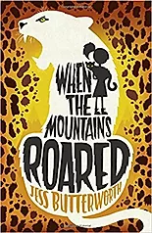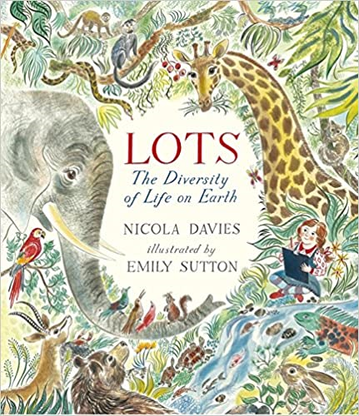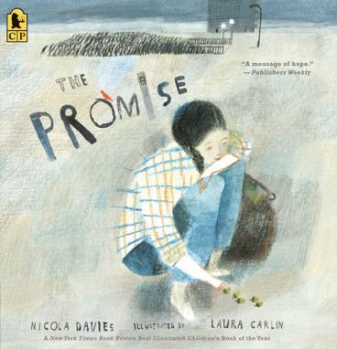 | Animals, including humans  Human Body Odyssey  (Werner Holzwarth)  Crocodiles Don't Brush Their Teeth  (Colin Fancy)  The little mole who knew it was none of his business  (Werner Holzworth and Wolf Erlbruch)  The incredible book eating boy  (Oliver Jeffers)  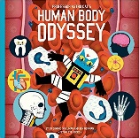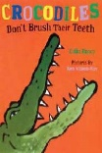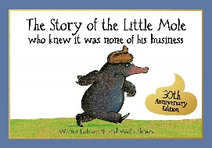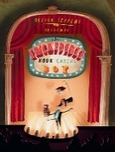 | Electricity  Until I Met Dudley  (Roger McGough)  Oscar and the Bird: A Book about Electricity  (Geoff Waring)  Electrical Wizard: How Nikola Tesla Lit Up the World  (Elizabeth Rusch)  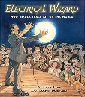  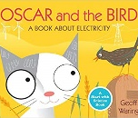  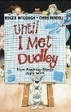
Sound  Horrid Henry Rocks  (Francesca Simon)  Moonbird  (Joyce Dunbar)  The Pied Piper of Hamelin  (Natalia Vasquez)  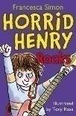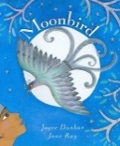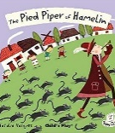 | States of Matter  Charlie and the Chocolate Factory  (Roald Dahl)  Once Upon a Raindrop: The Story of Water  (James Carter)  Sticks  (Diane Alber)  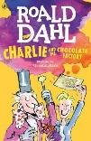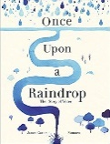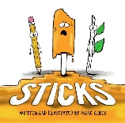 | For more texts linked to science, check out the websites below:  https://www.booksfortopics.com/science  https://www.stem.org.uk/teaching-science-through-stories  First news

Year 5
Living things and their Habitats  Charlotte’s Web  (E.B. White)  The Land of Neverbelieve  (Norman Messenger)  Life Cycles – Science Skills Sorted  (Anna Clayborne)  The ways of the wolf  (Smriti Prasadam-Halls)  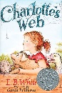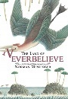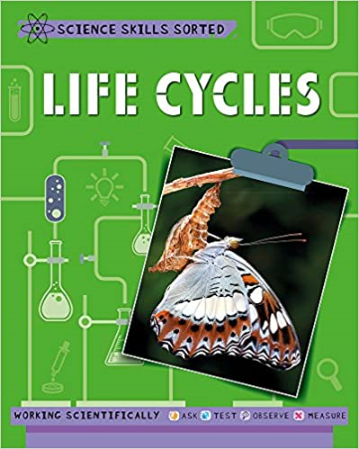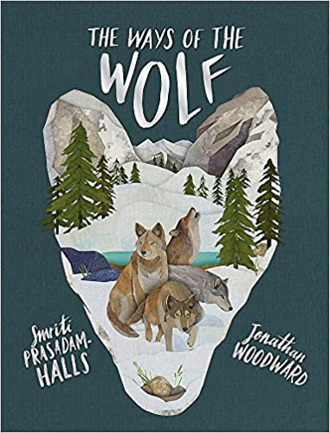 | Animals including Humans  Hair in Funny Places  (Babette Cole)  Giant  (Kate Scott)  You're Only Old Once!  (Dr. Seuss)  The Nowhere Emporium  (Ross MacKenzie)  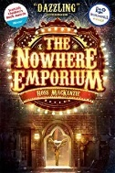  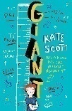  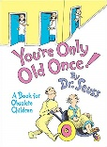  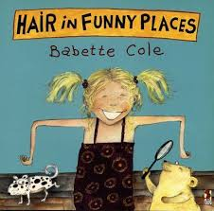 | Earth and Space  The Skies Above My Eyes  (Charlotte Guillain & Yuval Zommer)  George’s Secret Key to the Universe  (Lucy and Stephen Hawking with Christophe Galfard)  Cosmic  (Frank Cottrell Boyce and Steven Lenton)  Where once we stood  (Christopher Riley and Martin Impy)  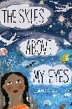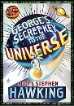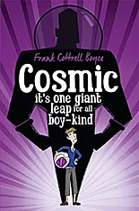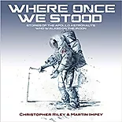
Forces  Leonardo's Dream  (Hans de Beer)  The Aerodynamics of Biscuits  (Clare Helen Welsh)  The Man Who Walked Between Two Towers  (Mordicai Gerstein)  The Tin Snail  (Cameron Mcallister)  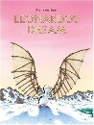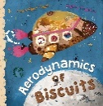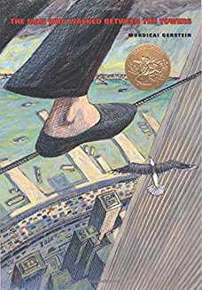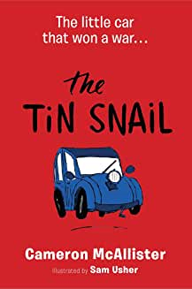 | Properties and changes of materials  Itch  (Simon Mayo)  Kensuke's Kingdom  (Michael Morpurgo)  The BFG  (Roald Dahl)  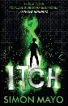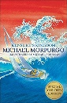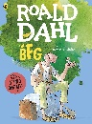 | For more texts linked to science, check out the websites below:  https://www.booksfortopics.com/science  https://www.stem.org.uk/teaching-science-through-stories  First news
Year 6
Living things and their Habitats  Beetle Boy  (M G Leonard)  Insect Soup  (Barry Louis Polisar)  Animal Atlas  (Lonely Planet Kids)  Our Planet  (Matt Whyman and Richard Jones)  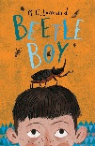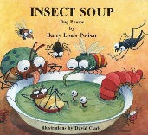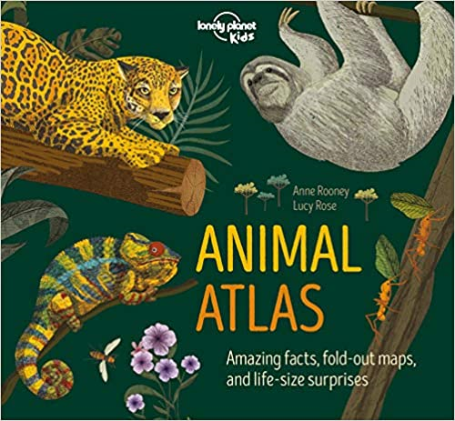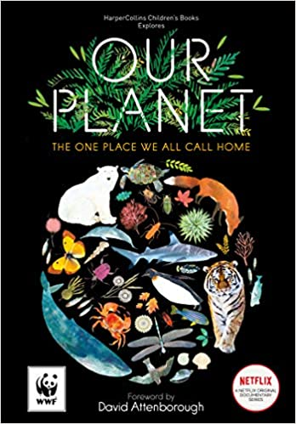 | Animals including Humans  Pig-Heart Boy  (Malorie Blackman)  Humanatomy  (Nicola Edwards)  A Heart Pumping Adventure  (Heather Manley)  Illumanatomy  (Kate Davies)  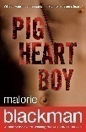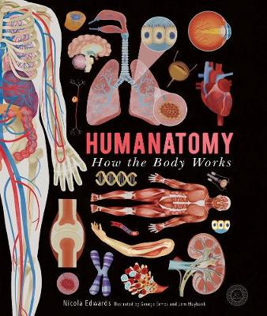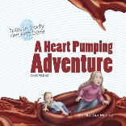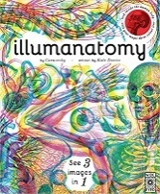 | Light  Letters from the Lighthouse  (Emma Carroll)  The King Who Banned the Dark  (Emily Haworth-Booth)  The light Jar  (Lisa Thompson)  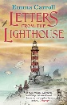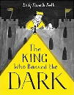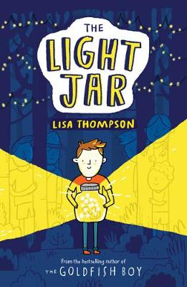
Electricity  Goodnight Mr Tom  (Michelle Mogorian)  The big book of science ideas  (Freya Hardy)  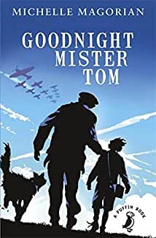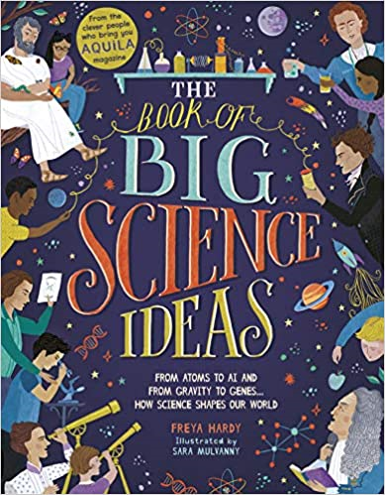 | Evolution  One Smart Fish  (Christopher Wormell)  On the Origin of Species  (Sabina Radeva)  Our Family Tree  (Lisa Westberg Peters)  Wonder  (R L Palacio)  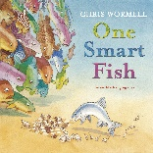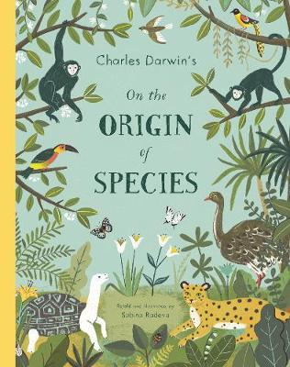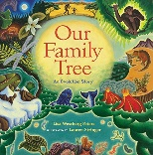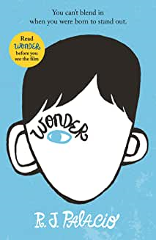 | For more texts linked to science, check out the websites below:  https://www.booksfortopics.com/science  https://www.stem.org.uk/teaching-science-through-stories  First news

